Alicia Bonavita

ID - 112393104

**1-2 - Identifying Database Design Consideration for Given Case Scenarios**

1. ABC School District would like to create a student on-line information and registration system to capture student-related information. The system needs to be designed as an on-line process to allow all new students to register on-line. It should also allow existing students to update and review all information. Create a list of important data that would need to be captured and stored in the student registration database.
   1. Student information such as full name, date of birth, address,gender,social security number.
   2. Parent and Guardian information such as names , relationship to student, contact information, emergency contact
   3. Enrollment information such as date of enrollment, assigned school district , previous school information
   4. Medical Information such as allergies, primary care physician, medications, medical conditions , insurance
   5. Some general consideration for this given scenario would be since it contains sensitive information to have some type of encryption and security compliance or protocols.
2. XYZ community would like to create a library management system. The objective is for the database to handle all transactions for the library. The database needs to store all the data that is relevant to managing the books, managing customers, and the day-to-day activities of the library. Create a list of important data that would need to be captured and stored in the library management database.
   1. Book information data such as - id/ISBN , title, author , publisher, genre,location
   2. Customer Information - Membership ID , name, address, phone number, email
   3. Book Transactions - transaction ID, due date, customer, and book ID, late fees
   4. Reservation and holds , book id , reservation number, customer ID
   5. Some other general considerations is depending on the library resources having also then list for digital items like audio books, digital books , and movies

**1-3 Identifying Database Models**

1. Hierarchical
2. Network model
3. Object- Oriented
4. Flat File
5. Relational

**1-4 Business Requirement**

1. LibBook is a successful digital library that rents CDs and provides access to the Internet for browsing their repository of articles and magazines. With the growing business, LibBook needs to enhance their information system to support proposed changes to the business. LibBook attracts new members easily and the number of members is growing rapidly. The membership base is not stable, however, which is a cause for concern. The main idea is to introduce the concept of membership at LibBook. Members will pay a membership fee and initially, there will be three types of membership (corporate, student, individual) although more may be introduced later. Student membership is free. Corporate and Faculty memberships incur a fee but entitle the member to privileges.The type of membership can be changed only if sufficient justification is provided.

**Your task is to identify the business rules and the associated constraints from the case scenario described.**

The business rules for this example are LibBook membership where constraints are place on the membership depending on the type of membership such as student, corporate, and individual. That justify the cost associated with the type of membership.

1. Star Care hospital is a multi-specialty hospital that caters to the needs of different patients. Every doctor registered with this hospital is assigned a unique ID that starts with the letter "DC". The hospital ensures that the doctors associated with them have a minimum of seven years of working experience. Every patient is required to register with the hospital on their first visit. When a patient arrives, a unique patient number starting with the letters "PT" is assigned to him/her.

**Your task is to identify the business rules and the associated constraints from the case scenario described**

The business rule is having doctors assigned a unique ID starting with DC . Where constraints are placed where that ID and DC code are linked to providers with a minimum of 7 years.

**2-1 - Relational Database Practice**

Identify the possible tables and associated fields from the given scenario:

Book.com is an online virtual store on the Internet where customers can browse the catalog and select products of interest.

1. Books
   1. Book ID
   2. Title
   3. ISBN
   4. Year
   5. Price
   6. Publisher ID
   7. Author ID
2. Authors
   1. Author ID
   2. Name
   3. address
3. Publishers
   1. Publisher ID
   2. Name
   3. Address
   4. Phone number
4. Warehouse
   1. Address
   2. Warehouse code
   3. Phone number
5. Stock
   1. Stock ID
   2. Book ID
   3. Quantity
6. Customers
   1. Customer ID
   2. Name
   3. Address
   4. Payment information
   5. Phone number
   6. Email
7. Shopping-cart
   1. Customer ID
   2. Cart ID
8. Cart-objects
   1. Cart item ID
   2. Book ID
9. Orders
   1. Order id
   2. Customer ID
   3. Payment information
   4. Cart item ID
10. Items-order
    1. Order item id
    2. Order item
    3. Book id
    4. Quantity

**2.**

### 1. Customers Table

* Customer ID
* Name
* Address
* Phone Number
* Email

### 2. Products Table

* Product ID
* Product Name
* Description
* Price
* Quantity

### 3. Suppliers Table

* Supplier ID
* Supplier Name
* Address
* Phone Number
* Email

### 4. Orders Table

* Order ID
* Customer ID
* Order Date

### 5. Order_Items Table

* Order Item ID
* Order ID
* Product ID

### 6. Invoices Table

* Invoice ID
* Order ID
* Date
* Total

### 7. Invoice_Items Table

* Invoice ID
* Invoice ID
* Product ID
* Quantity
* Amount

### 8. Payments Table

* Payment ID
* Customer ID
* Amount

### 9. Payment_Details Table

* Payment ID
* Invoice ID

**2-2 Conceptual and Physical Data Models**

1. Provide 5 reasons for creating a conceptual data model
   1. It provides informations needed for functionality for a data model
   2. It outlines the necessary information for a business model
      1. Which can help reflect on current and future data needs
   3. Identifies what type of data/entities
      1. As well as define relationship among entities
   4. Acts as the blueprint for the physical thing
   5. It can shape business rules and concepts
2. List 2 examples of a conceptual model and a physical model
   1. Conceptual
      1. Entity Relationship Diagram
      2. Entity Relationship Model
   2. Physical Model
      1. Physical Data Model Diagram
      2. Database - Flat , relational schemas

**2-3 Entities and Attributes Practice**

1. Create the entities for the school of management systems
   1. Students
   2. Course
   3. Instructors
      1. Departments
      2. Classroom
   4. Enrollment
   5. Schedules
2. Add the appropriate attributes as well as the optionality (*, °) to all the entities of the Academic Database
   1. Students *
   2. Course *
   3. Instructors *
   4. Departments°
   5. Classroom °
   6. Enrollment *
   7. Schedules *

**2- 4 Unique Identifiers Practice**

Exercise 1: Identify the Unique Identifier and corresponding Primary keys

1. How do you find a particular song in the whole collection? What would be a unique identifier for SONG?

Song_ID

2. Think about all the students in the classroom. Each student is described by several traits or attributes. Which attribute or attributes allow you to pick a single student from the rest of the class?

Gender

Date of Birth

Email Address

3. For each entity, select the attribute that could be the unique identifier of each entity.

Entity: STUDENT

Attributes: **student ID**, first name, last name, address

Entity: MOVIE

Attributes: title, date released, producer, **director**

Entity: LOCKER

Attributes: size, **location,** number

Exercise 2: Identify the Unique Identifiers and add to the ERD

1. Use the Academic Database ERD from the previous exercises to identify the following:

a. Unique Identifiers

Student

Faculty

Course

b. Candidate Unique Identifiers

Course

Department

**2-5 Relationship Practice**

1. Each EMPLOYEE must be assigned to one and only one DEPARTMENT.

Each DEPARTMENT must be responsible for one or more EMPLOYEEs

1. A Person resides in one TOWN.
2. A Town can have many PERSONs living in it.
3. A Person can visit many towns
4. Towns can have many visitors [persons]
5. A Mayor is a person and can only govern 1 town

Write the ERDish for each of the relationships in the Academic Database including relationship names, optionality and cardinality. Draw the ERD including the relationships

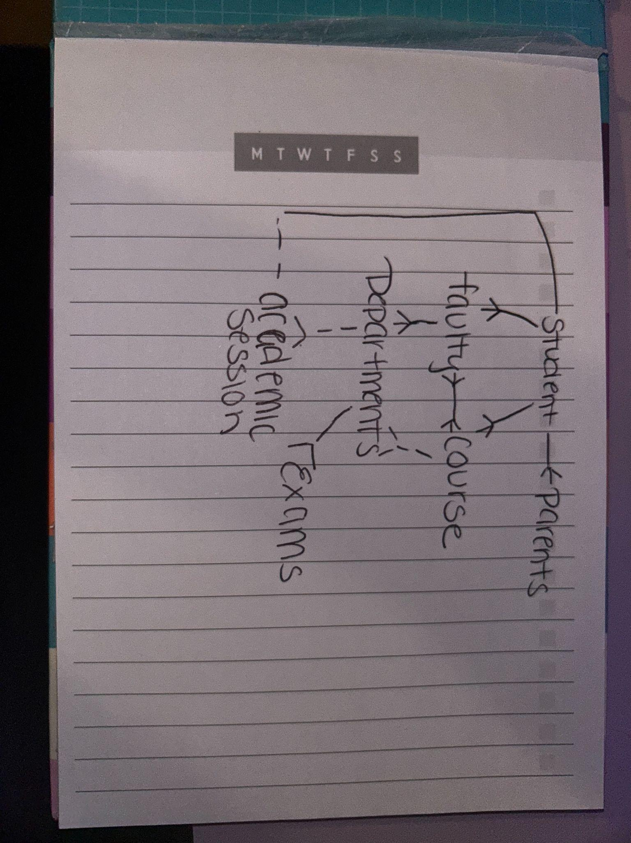

**2-6 Identify the components in a given simple ERD**

1. Identify the possible Entities and Attributes from the given scenario.

A company has several departments. Each department has a supervisor and at least one employee. Employees must be assigned to at least one, but possibly more departments. At least one employee is assigned to a project, but an employee may be on vacation and not assigned to any projects. The important data fields are the names of the departments, projects, supervisors and employees, as well as the supervisor and employee number and a unique project number

**Department**

* Attributes:
  + Department Name
  + Supervisor

**Supervisor**

* Attributes:
  + Supervisor Name
  + Supervisor Number

**Employee**

* Attributes:
  + Employee Name
  + Employee Number

**Project**

* Attributes:
  + Project Name
  + Project Number

1. Read the given business scenario. Draw the entities HAIRSTYLIST and CLIENT. List the attributes associated with each entity and specify whether they are mandatory or optional. Identify the UIDs. Follow the diagramming conventions discussed. State the ERDish for the relationships.

“In our salon, we have a number of hairstylists. They are all salaried employees, so we keep a record of their first name, last name, address, phone number, social-security number, and salary. During the course of a day, a hairstylist may see several clients. On a slow day, a hairstylist may not work on anyone at all. We have several walk-in clients, and they each get assigned to one hairstylist. We just ask for their first name. We also have customers who call to make an appointment. When they do this, we ask for their first name, last name, and phone number. We also ask if they would like a specific hairstylist. If they have no preference, we assign one for them. Of course, they are allowed to switch to another hairstylist for their next visit to the salon. We are interested in tracking the daily appointments -- which stylist works on which client during a given day

* Each HAIRSTYLIST must be assigned to one or many CLIENTS

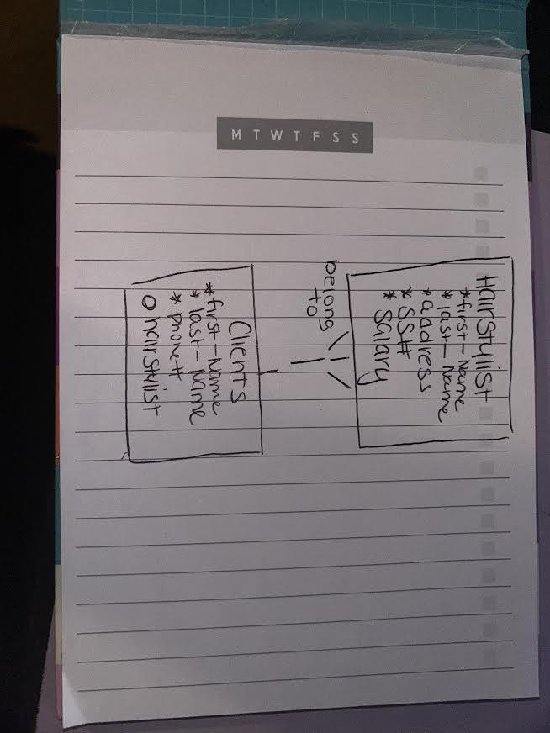

1. Read the given business scenario. Draw the entities TEACHER and COURSE and CLASS. List the attributes underneath each entity. Specify whether they are mandatory or optional. Identify the UIDs. . State the ERDish for the relationships.

“We have several teachers at our school. A teacher can be assigned up to three classes per semester. If a teacher is on sabbatical, he doesn’t teach that semester. We keep a record of the teacher’s first name, last name, address, phone number, and email address. Our school offers many courses -- such as Data Modeling, Introduction to SQL, Trigonometry, Physics, and Biology. Each course has a code. For example: Data Modeling would be DM001, Trigonometry would be TR004, etc. During each semester, a course may be taught in several classes -- so there could be two classes of Physics, three classes of Biology, etc. Each class can be taught by only one teacher. We assign a unique ID for each class, and we also keep track of the day it is taught, the time, and the classroom.”

* Each TEACHERS must be assigned to one or many COURSE
* Each TEACHER must be assigned to one and only one CLASS
* Each COURSE must be assigned one or many CLASS

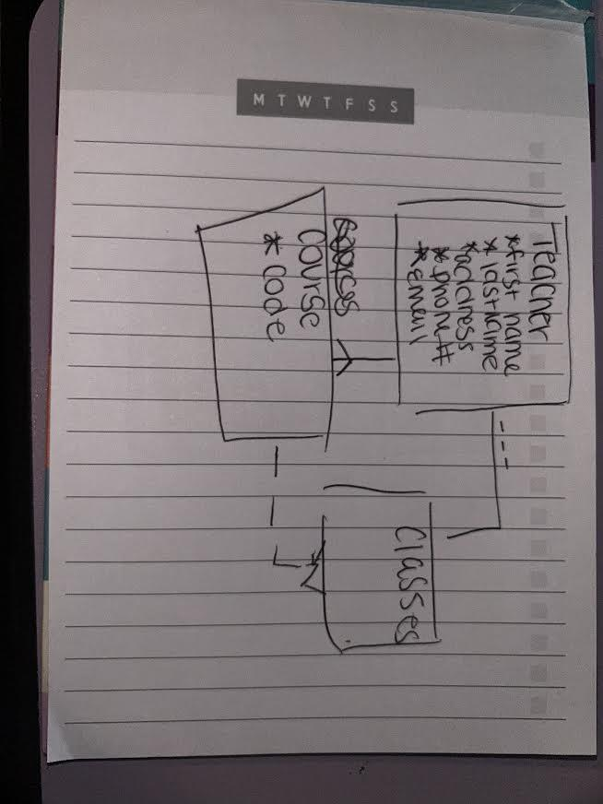

**3-1 More with Relationships**

Exercise 1 Q 1-3

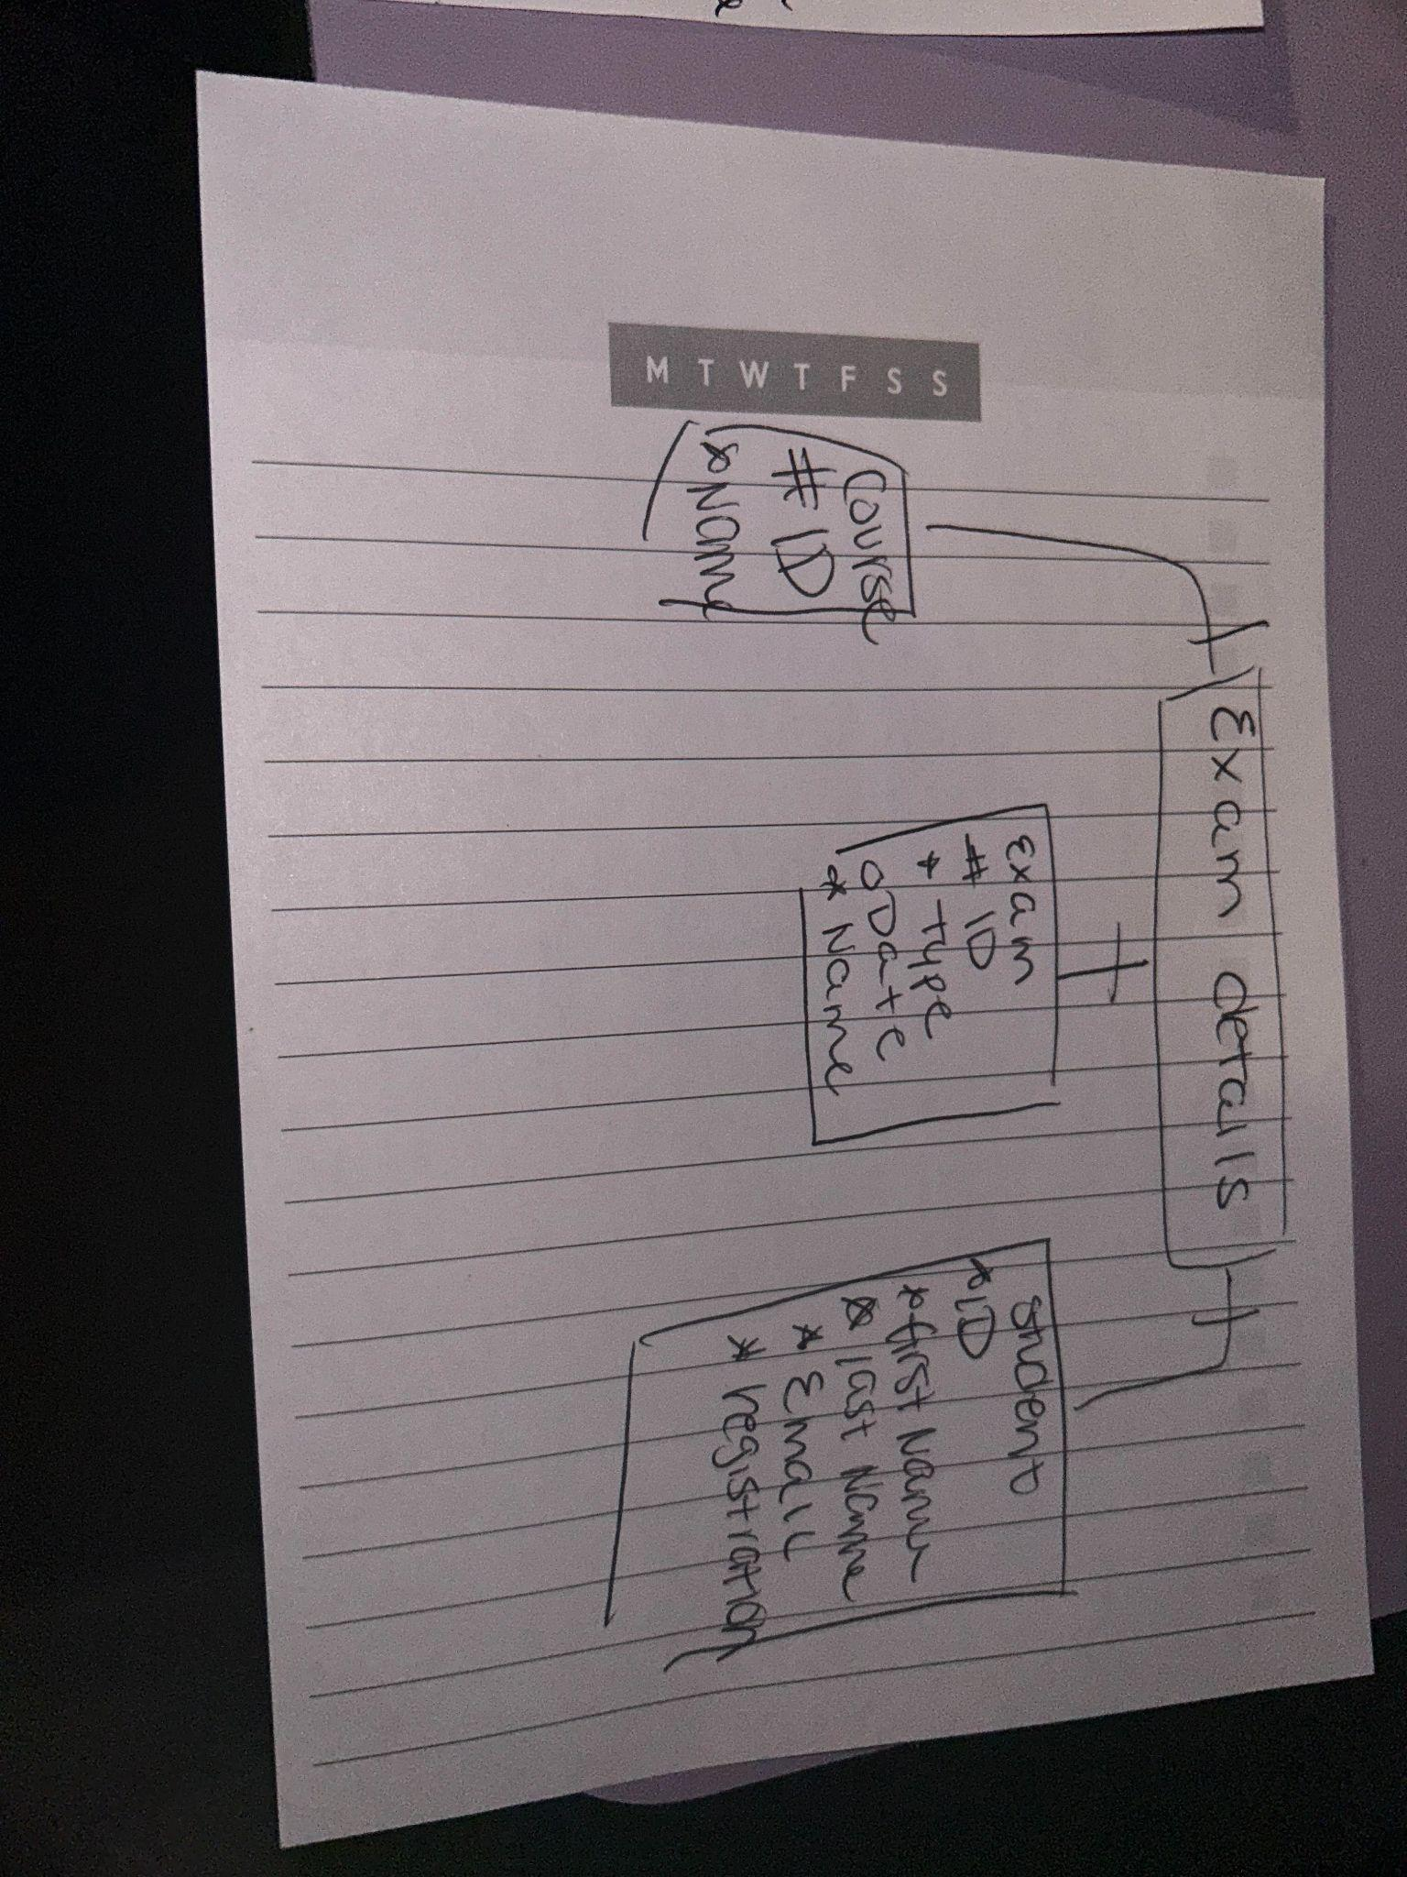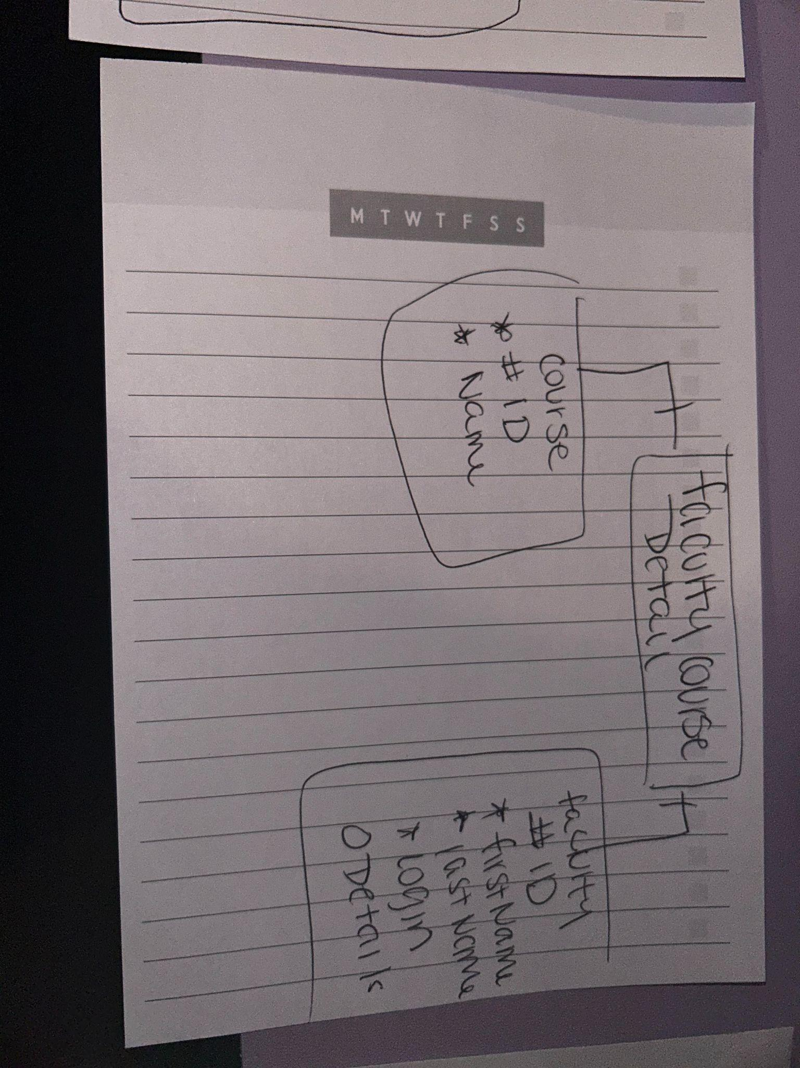

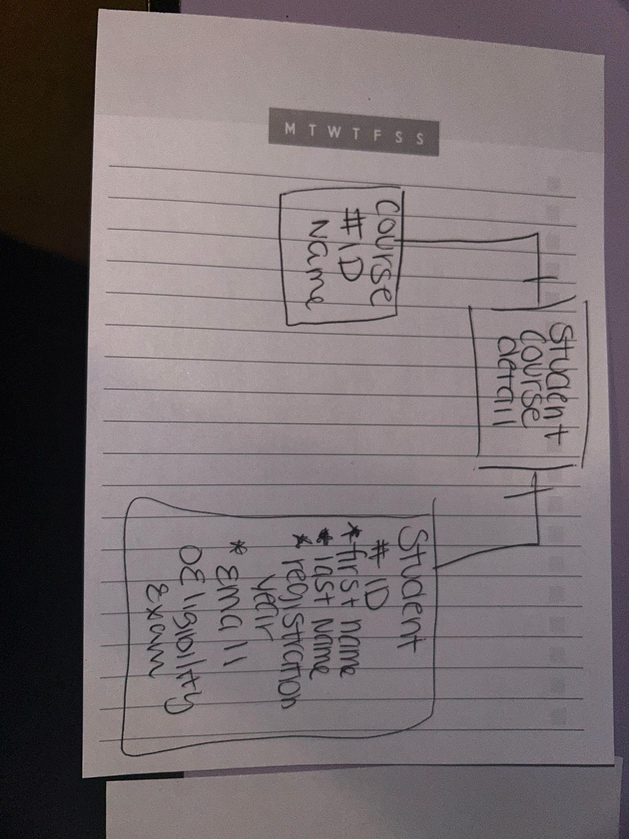

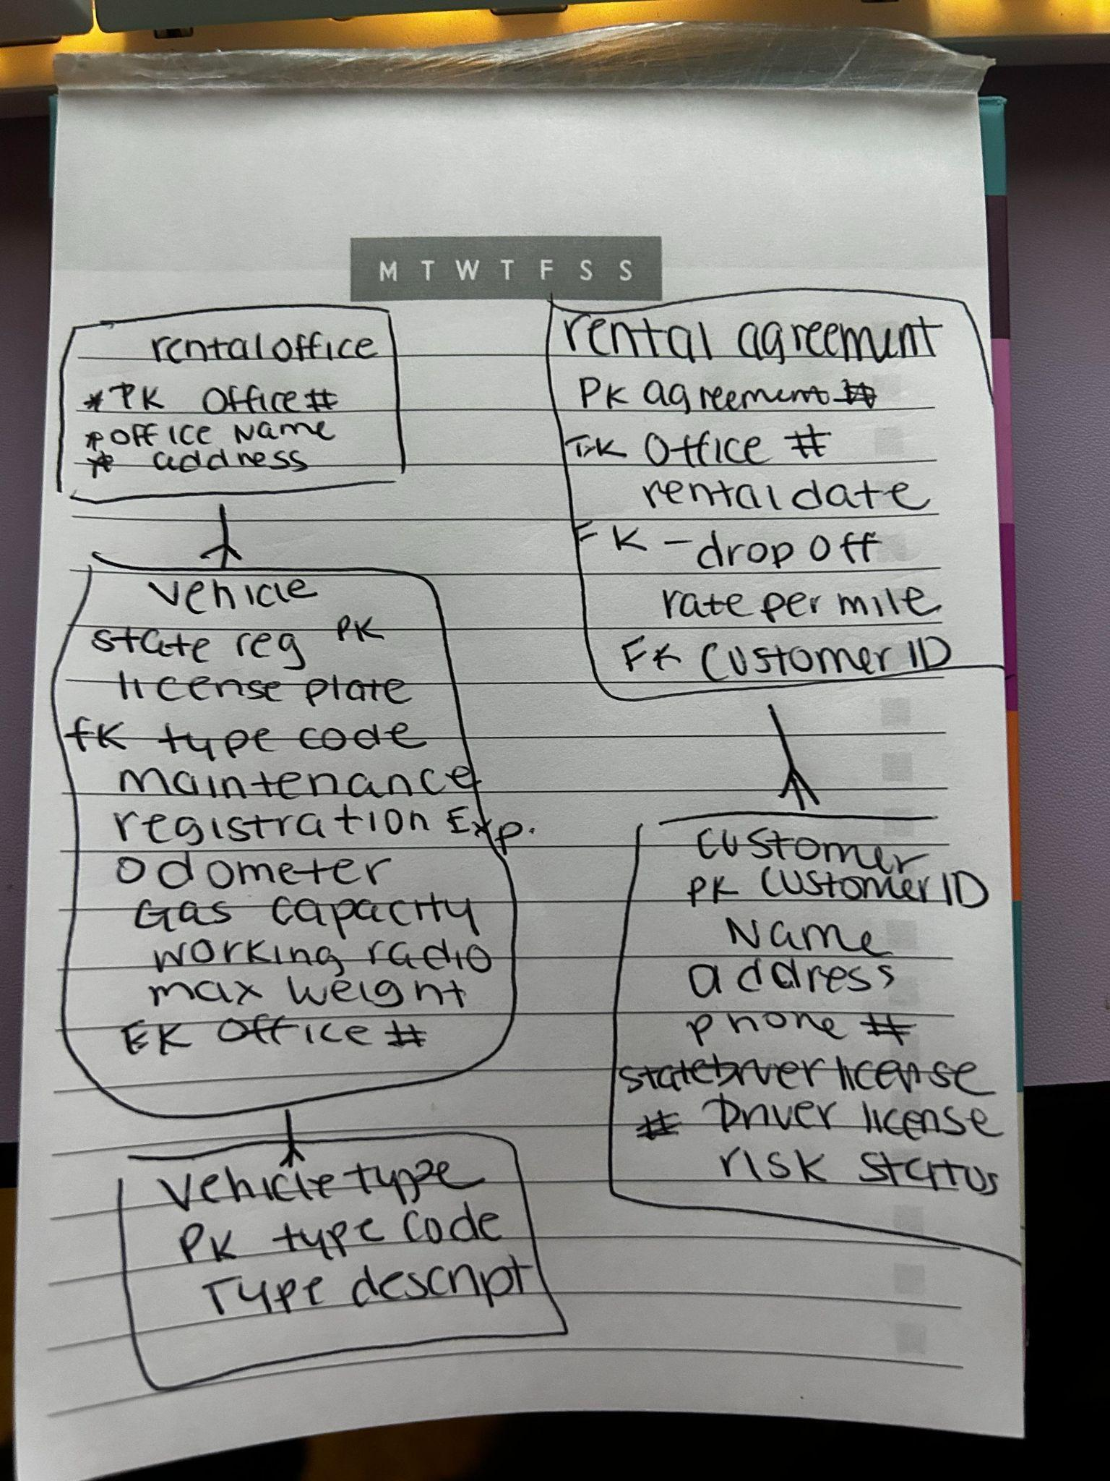

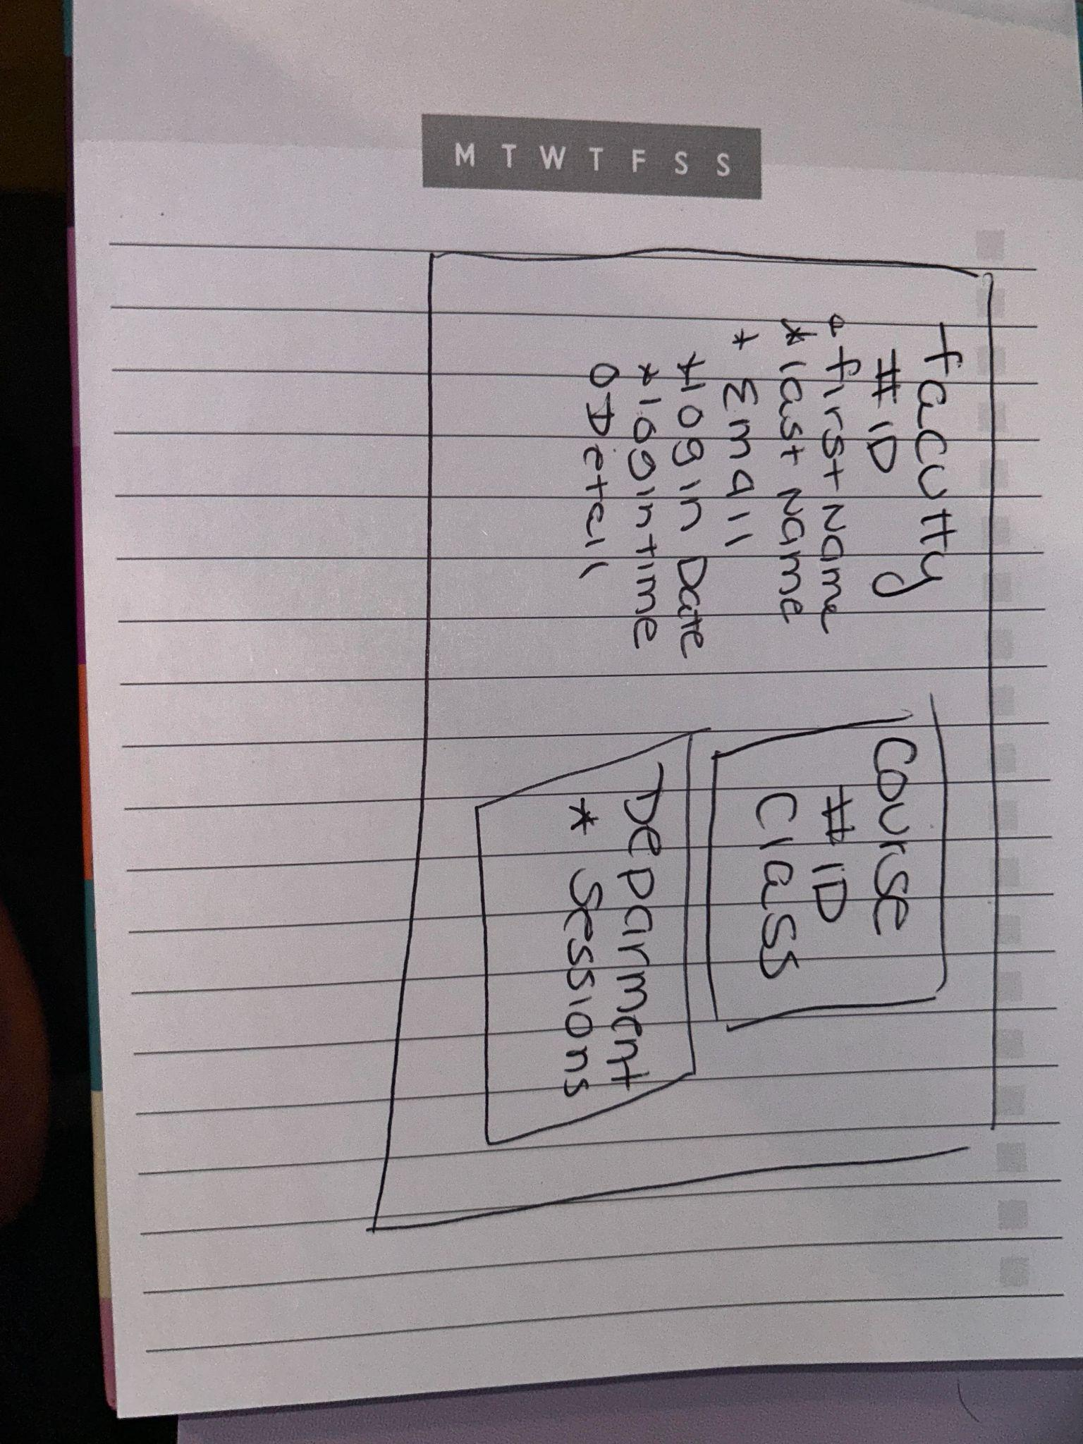

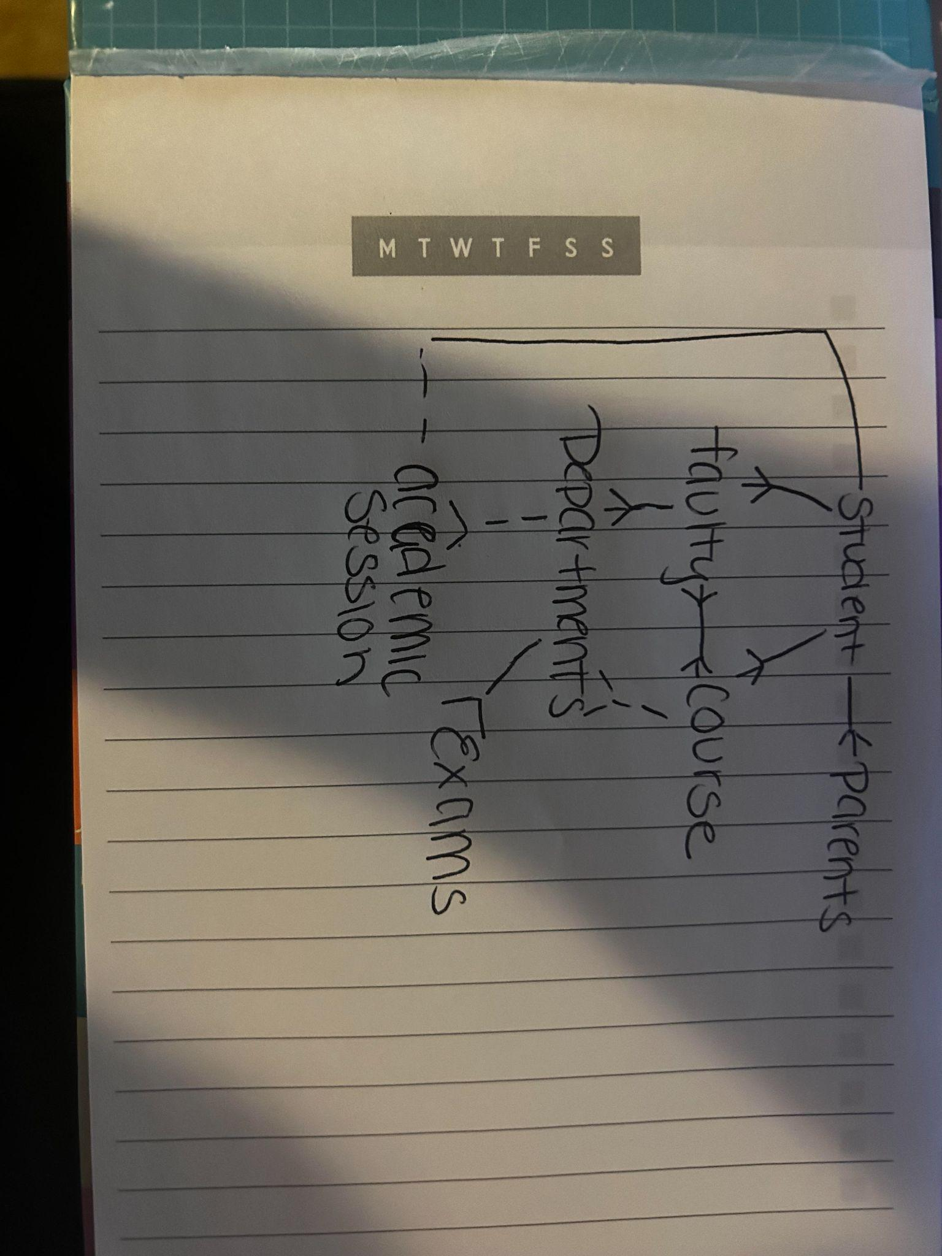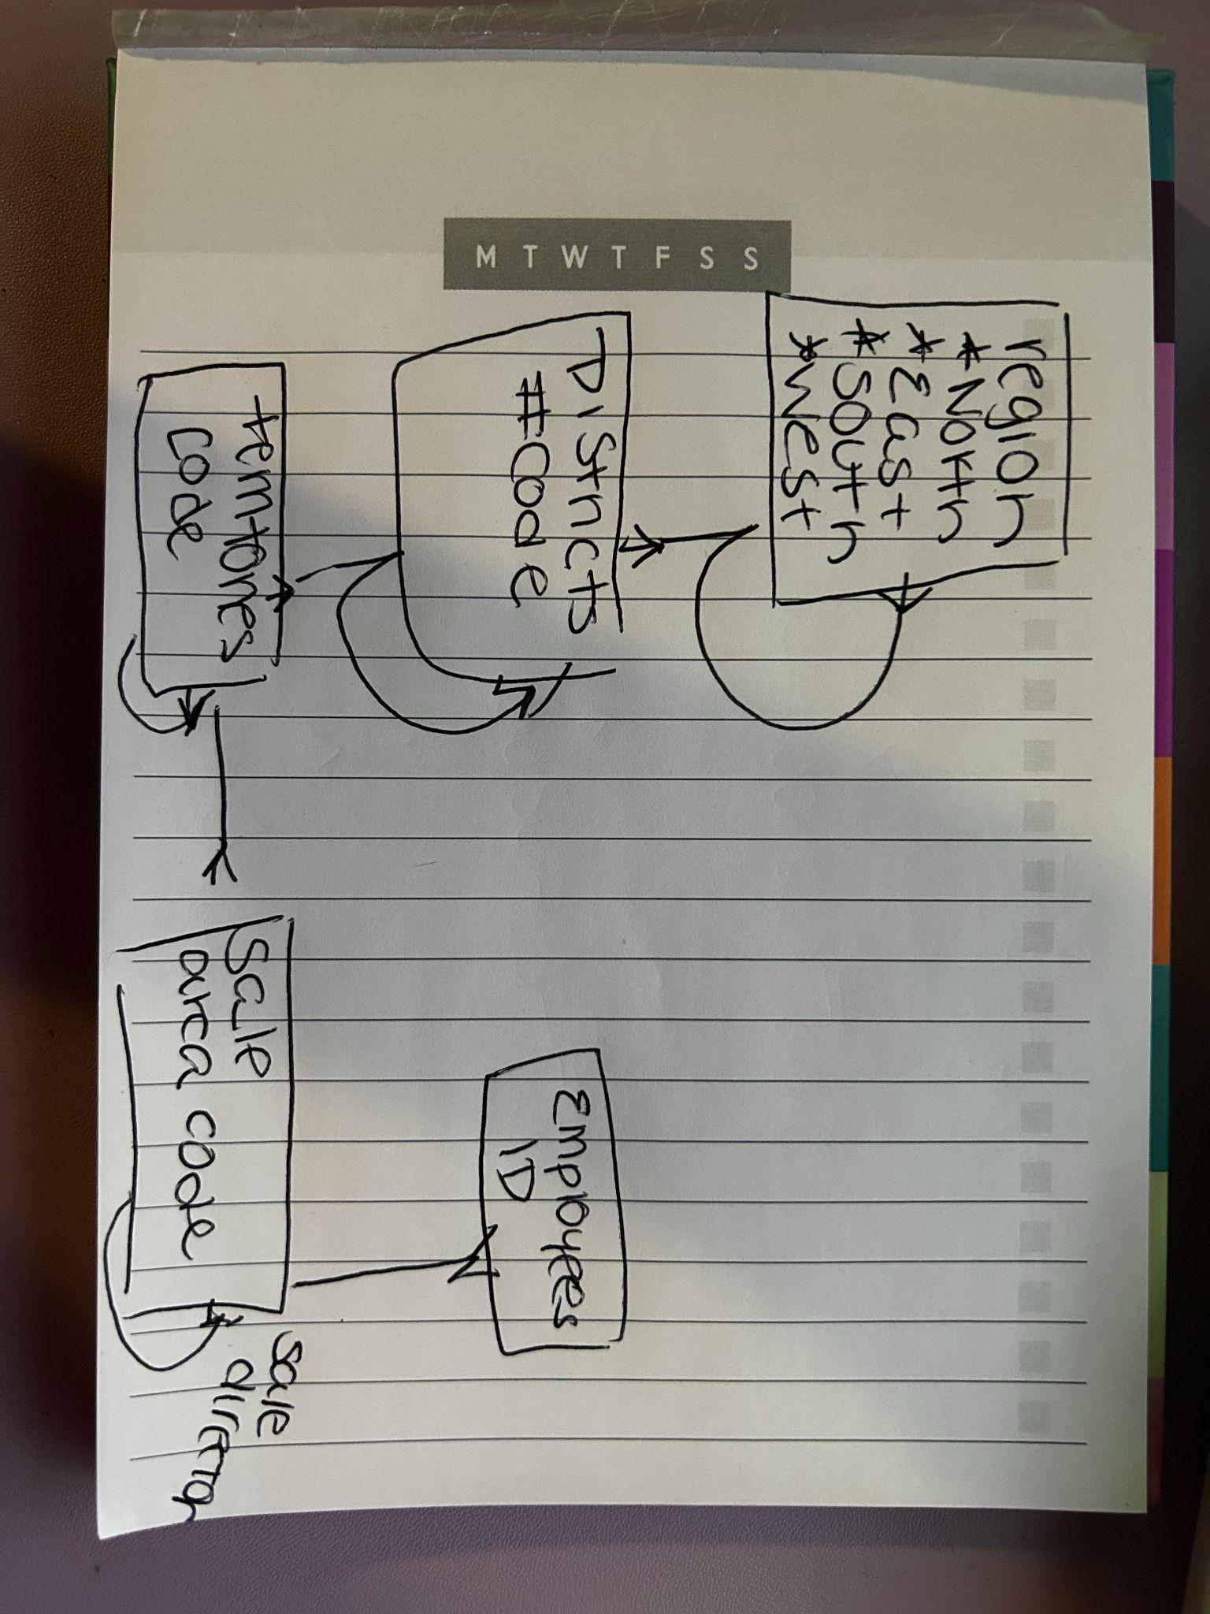

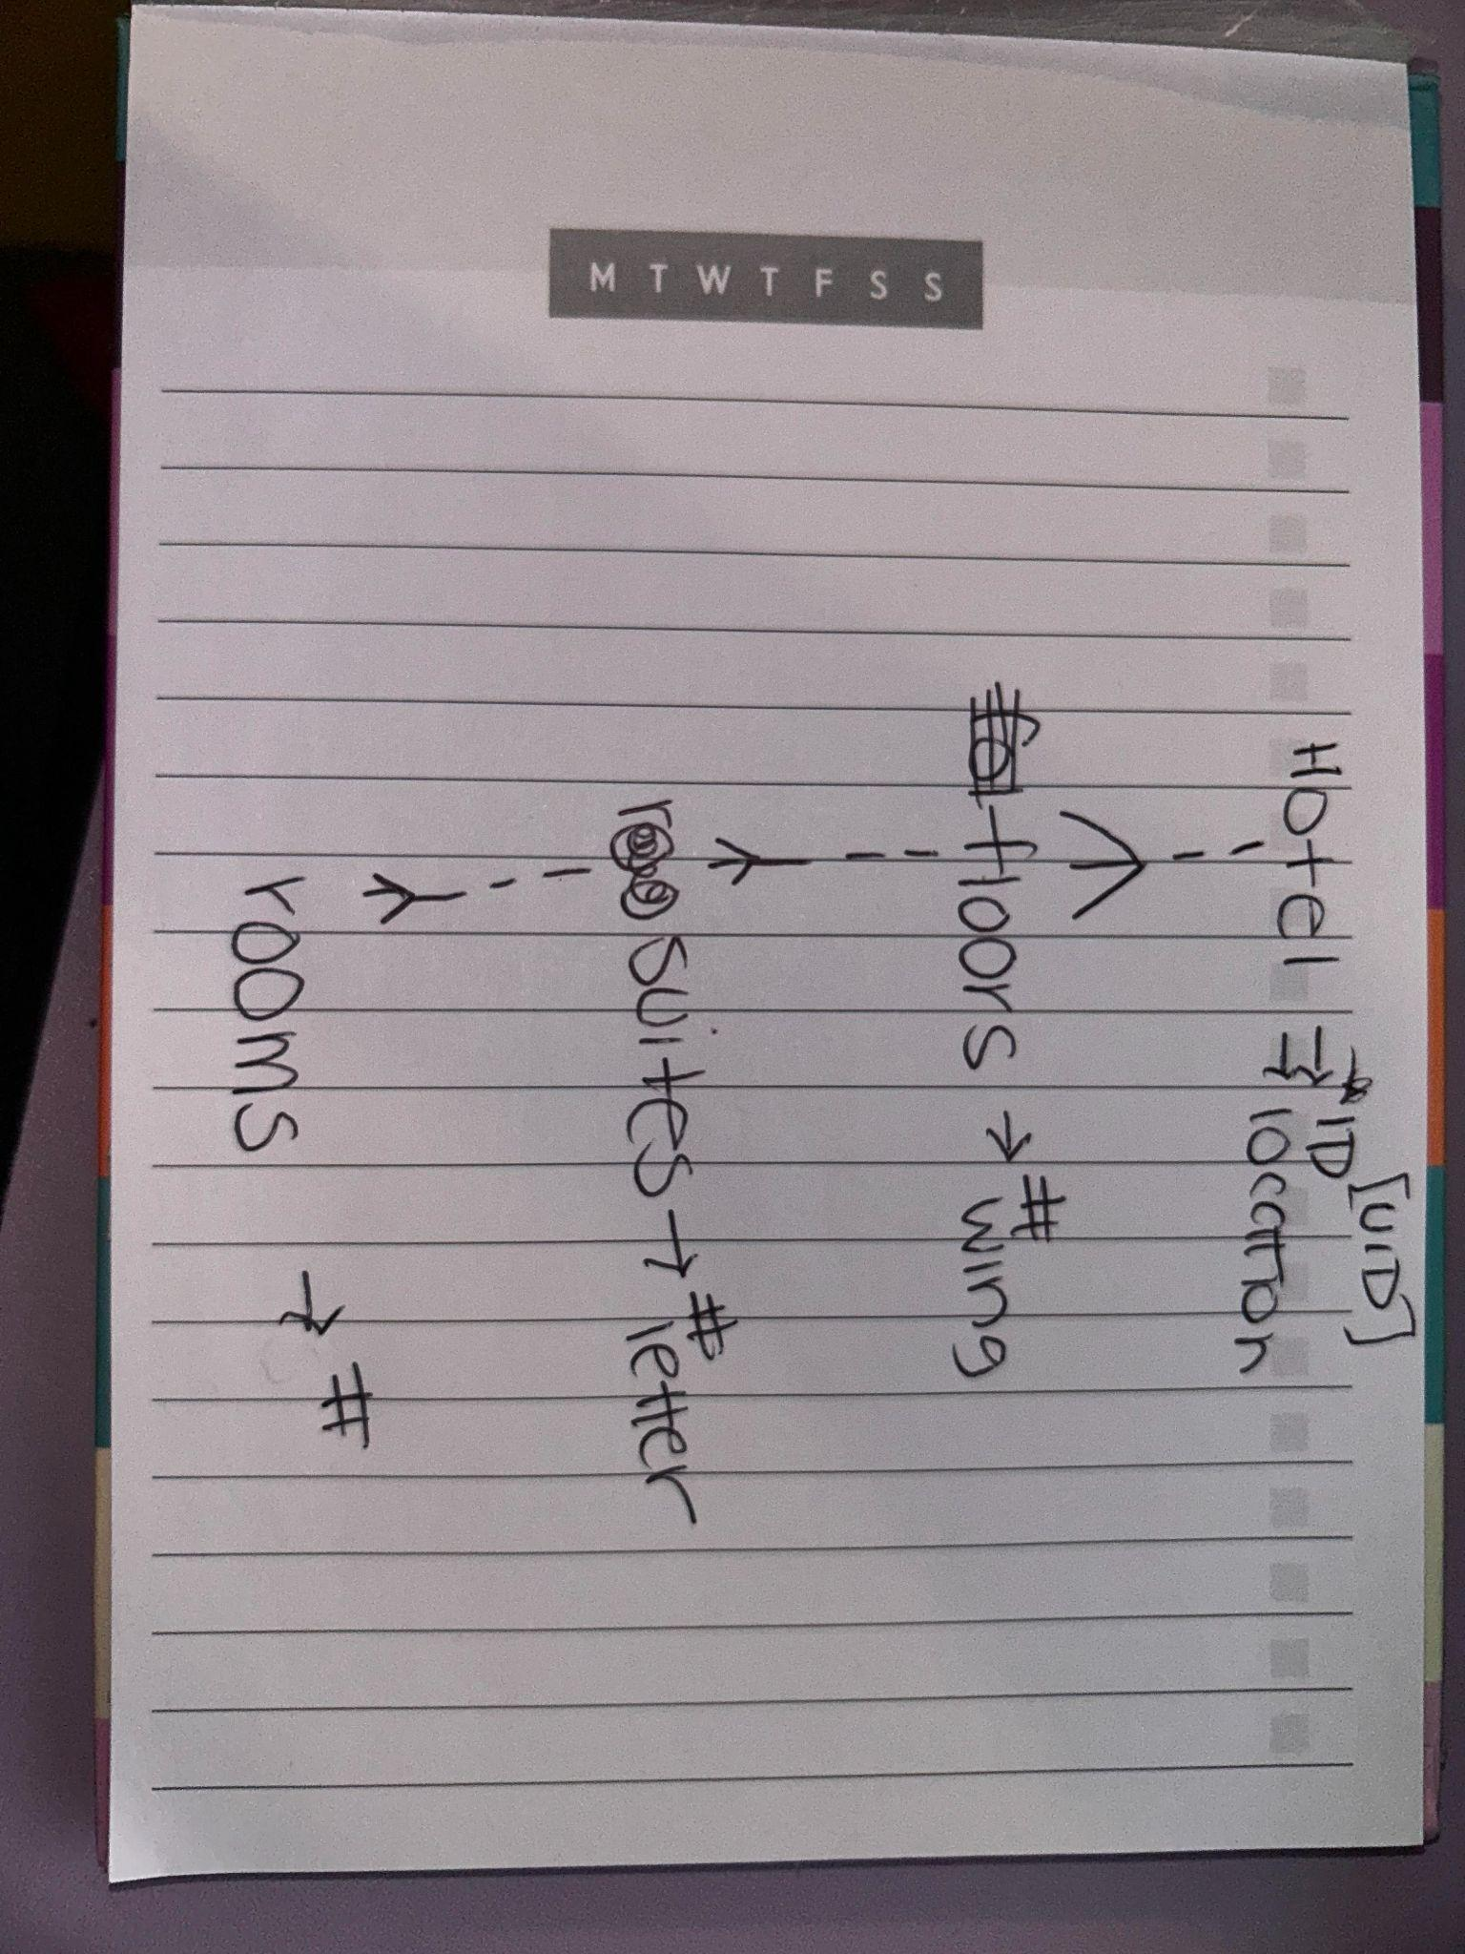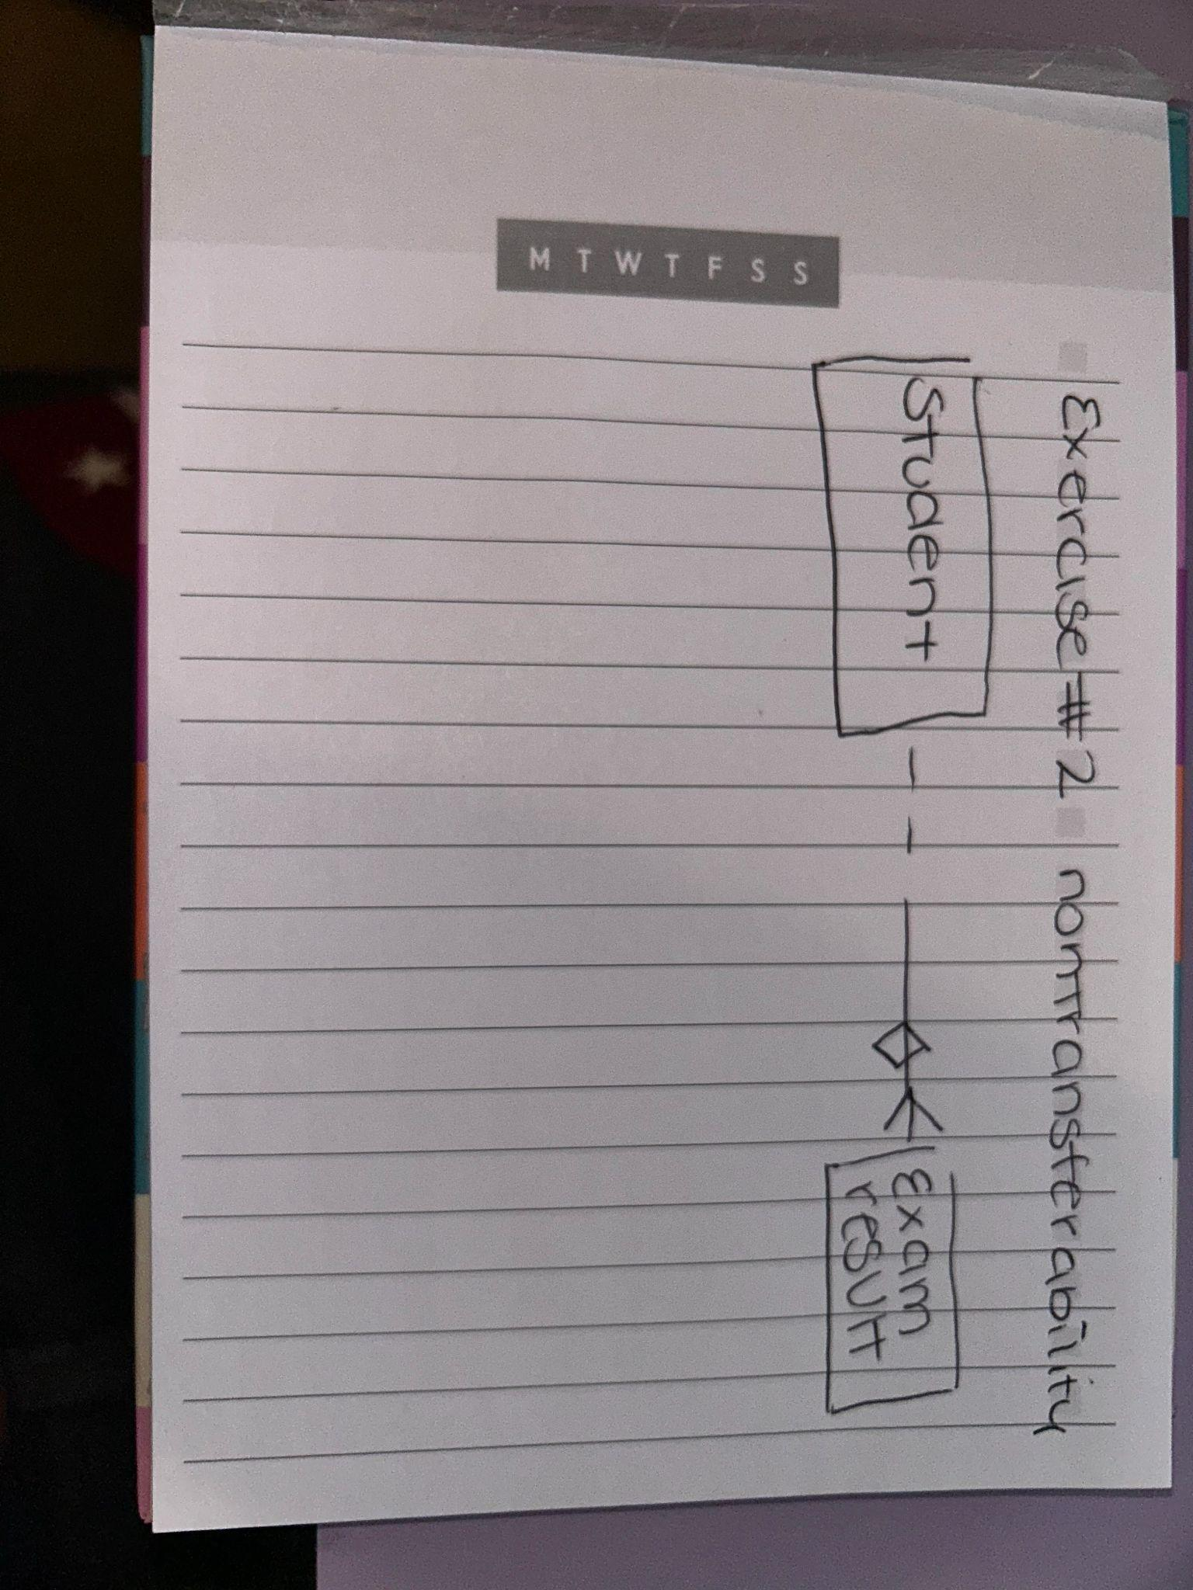

3-2 Tracking data changes practice

1. For the first task example for student

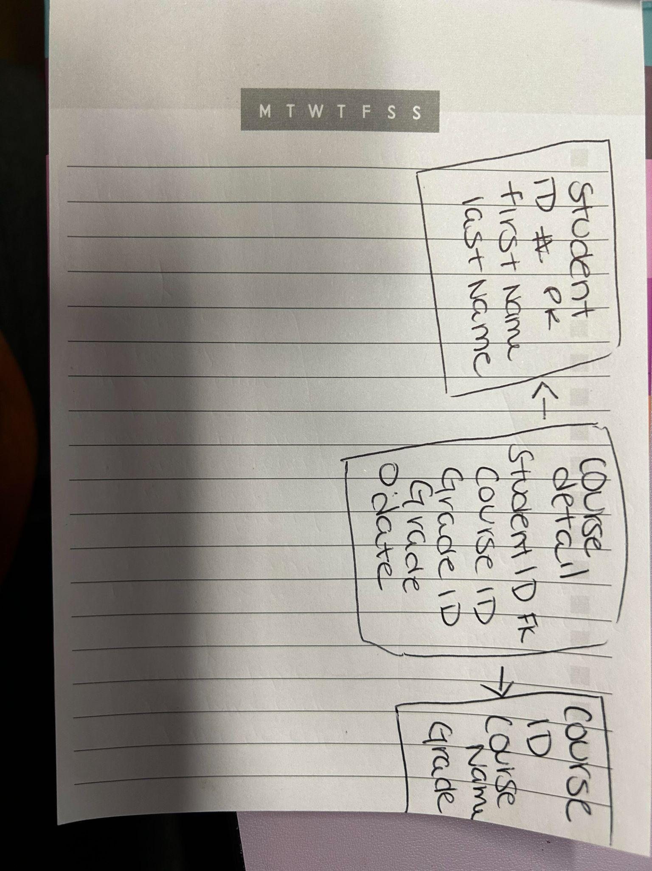

1. Examine ERD representing classroom assignments for different exams
   1. Why is start time part of the UID of assignments?
      1. Start time is a UID for assignment because it is a tracking attribute for that given assignment and specifies an entity at a specific period of time. Differentiating if the exams are in progress, not in progress, or completed.
   2. Name 3 time-related constraints
      1. End time must be later than start time
      2. Date of exam has to be the same for the exam and classroom
      3. Start time must be earlier than end time

**3-3 Normalization and Business Rules**

Exercise 1

1. Table 1 breaks the 1NF rule because it contains multiple values. To normalize this table I would create an Item color table which would contain item ID’s PER color. Making Item ID the primary key for this table and ensuring that each instance contains a unique and no duplicates. Then you can make an Item ID to price because on the color table you will now be able to indicate which item color corresponds with which price.
2. To bring this table to 2NF , We need to remove location from this table because it's a non-key attribute. To put this into 2NF we would make 2 separate tables with supplier ID and Store ID. Then a Second table with store ID and location details.
3. To bring this table in 3 NF Category Desc has no functional dependency on the primary key - Book ID. Therefore the way to fix this is to divide this table into 2 tables. Table 1 with book ID , category and price. Then creating a foreign key using Category ID to make a different table with Category ID and Category Desc.

Exercise 2

1. For students - It should be separated into another block and add a Student attendance attribute and place number for working days , number of days off, and eligible for exam. This is because it breaks first normal form because student and academic session are redundant
2. There should also be a faculty login because it also breaks 1 NF for faculty. Since faculty login is repeated the best way is to add an entity for faculty login.
3. Exam block break 3 NF because there is no functional attribute for exam name and description. So there should be an added block defining exam type to include type , name and description next to Exams.

Exercise 3

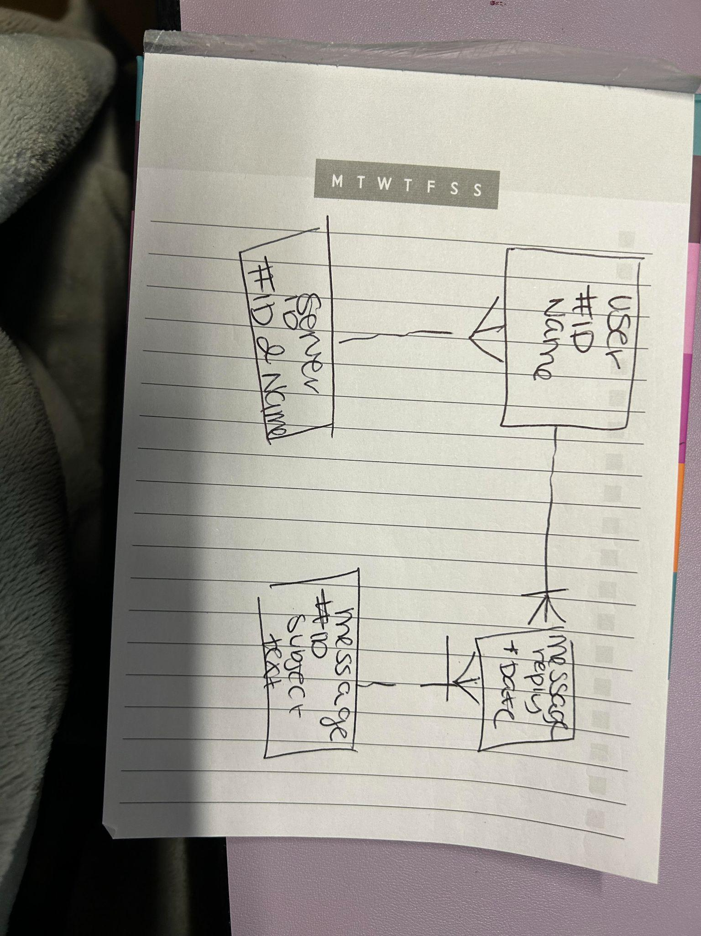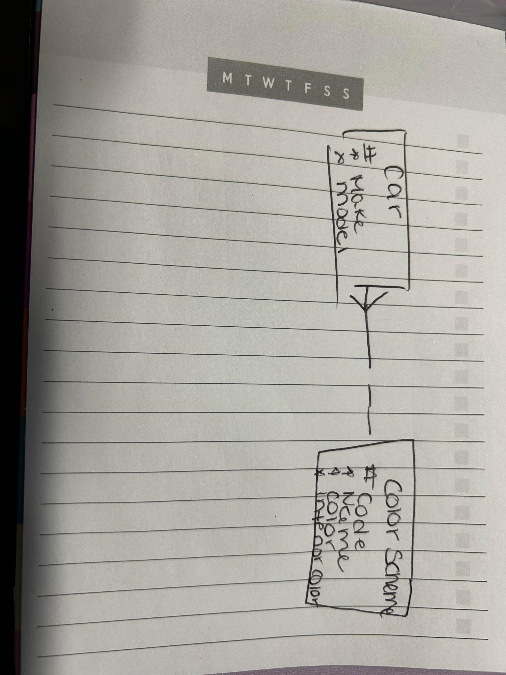

Exercise 4

* Customer can have 1 or many orders
* Customers must have an email address
* Orders can have - or many products
* Payment can only have 1 and only 1 order association
* Delivery can only have 1 and only 1 order

Exercise 5

1. All teachers in our school must possess a valid teaching certificate = structural business rule
2. Each department must offer a course = structural business rule
3. Approval of travel request to an event must be signed by the project manager of the event = procedural BR
4. A customer may make numerous payments on account = structural BR
5. Machine operator may not work more than 10 hours a day = programmatic BR
6. Rent is calculated from rent rate * number of days = programmatic BR
7. Customers can have 0 , one or many orders = Structural BR
8. Total cost is calculated from sum of insurance amount , rental amount , and late charge = programmatic BR
9. Customers debt must not exceed customer credit limit = programmatic BR

3-4 Data Modeling Terminology and Mapping practice

1. Matching
2. Instance = row
3. Entity = Column
4. Relationship = table
5. Attributes = unique key
6. Primary UID = primary key
7. Secondary UID = Foreign key
8. ER model = physical design

B. Identifying notation

1. Pk - primary key
2. Fk - foreign key
3. Uk - unique key
4. * - Mandatory
5. o - optional

C. short name conventions

1. Author - ‘auth’
2. Publishers - ‘pub’
3. Customers - ‘cust’

D.

1. Song
   1. Release date
   2. Type
   3. Title
2. Event
   1. Venue
   2. Description
   3. Title
3. Customer
   1. First name
   2. Last name
   3. Email
   4. Phone number

Exercise 2 - Mapping Academic Database

Entities

1. Parent Information
   1. fk - ID
2. Student
   1. pk - ID
3. Student Attendance - UID
4. Academic session - UID
5. Course -UDI
   1. Pk ID
6. Student Course details -UID
7. Department
8. Exam Results
   1. Online
   2. Seated
9. Exam
10. Exam type - UID
11. Faculty details -UID
12. Faculty
    1. Pk- ID
13. Faculty login - UID
14. Department